BUG REPORT
Zoiko Payroll Website – Chatbot (Global Payroll AI Concierge)
Project | Zoiko Payroll Website Chatbot
Prepared By | Siddhartha, Automation Test Engineer
Date | October 30, 2026
Total Bugs | 2

Bug Summary
ID | Title | Severity | Status
BUG-01 | No answer generated for some questions; asks user to sign in | High | Open
BUG-02 | "Check your country" section disabled for some questions | High | Open

BUG-01: No answer generated for some questions; asks user to sign in
Bug ID | BUG-01
Severity | High
Status | Open
Description | For some questions, such as "Where is Zoiko Payroll available?", "Which accounting systems integrate?" and "Which countries do you currently support?", the chatbot asks the user to sign in instead of answering. Other questions, such as pricing plans and booking a demo, get "I can't confirm that from current Zoiko Payroll information".
Screenshots
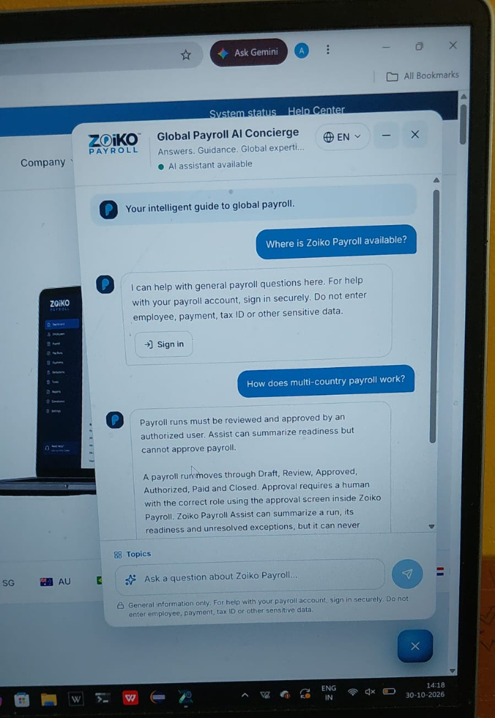  Figure 1: "Where is Zoiko Payroll available?" asks to sign in | 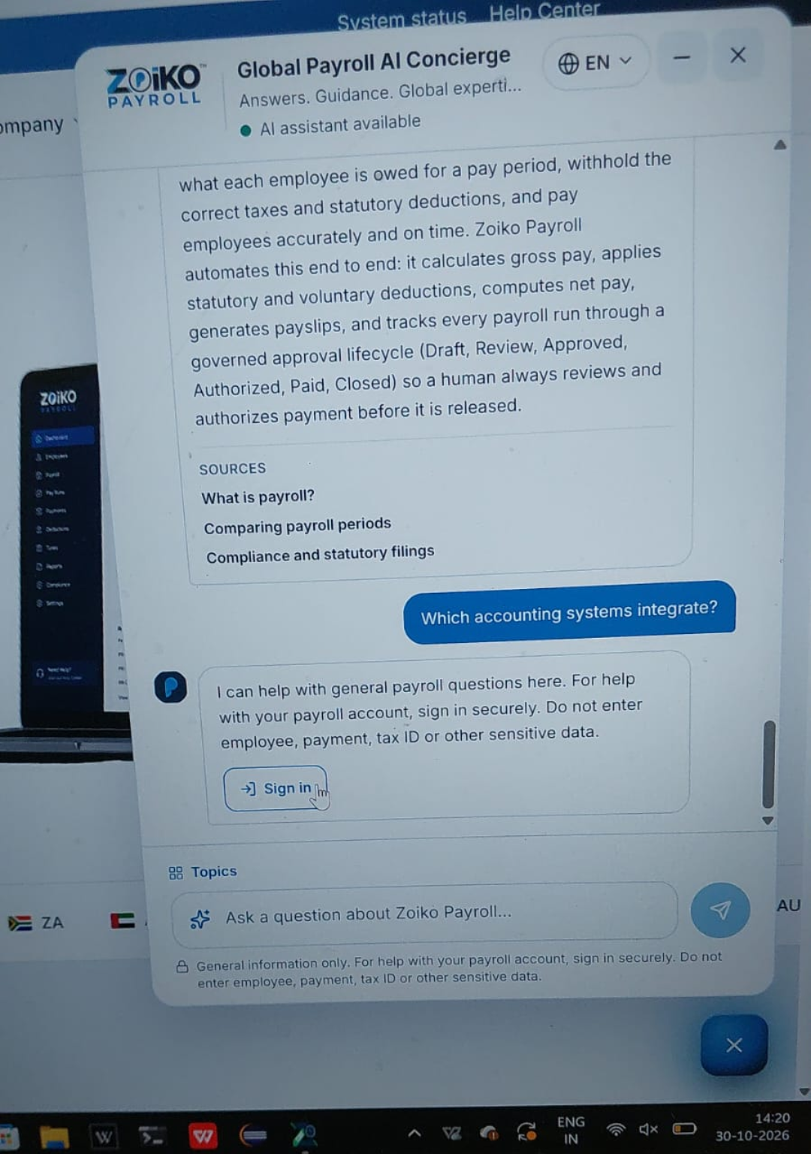  Figure 2: "Which accounting systems integrate?" asks to sign in
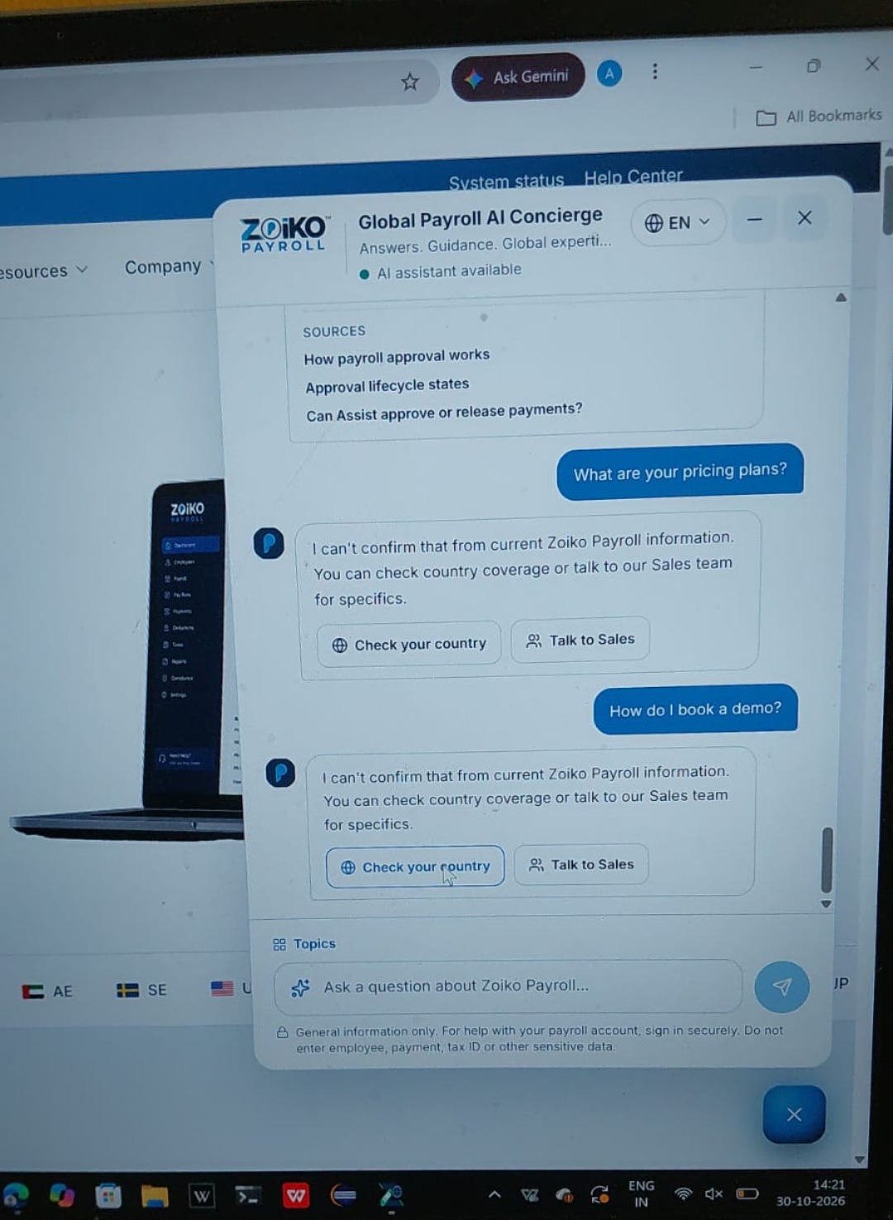  Figure 3: No answer for pricing plans and demo booking | 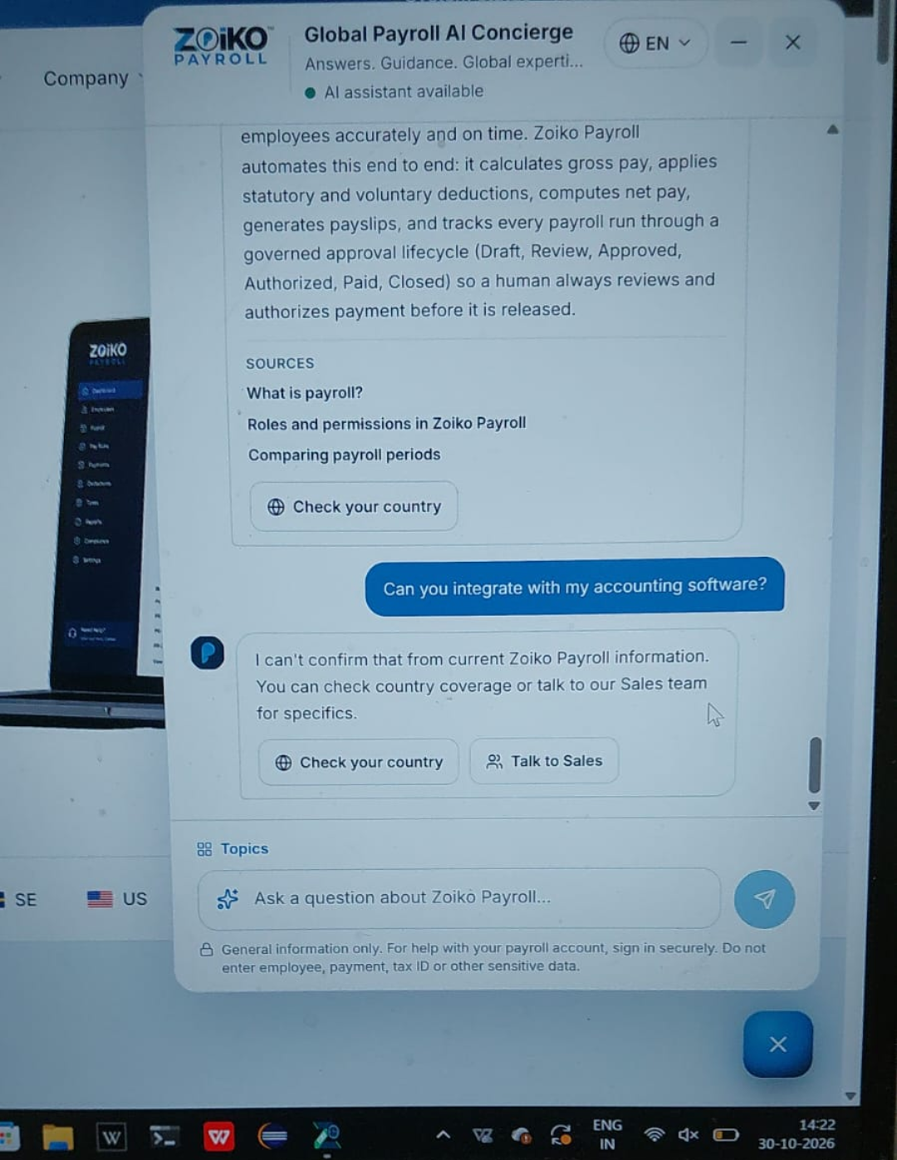  Figure 4: No answer for accounting software integration
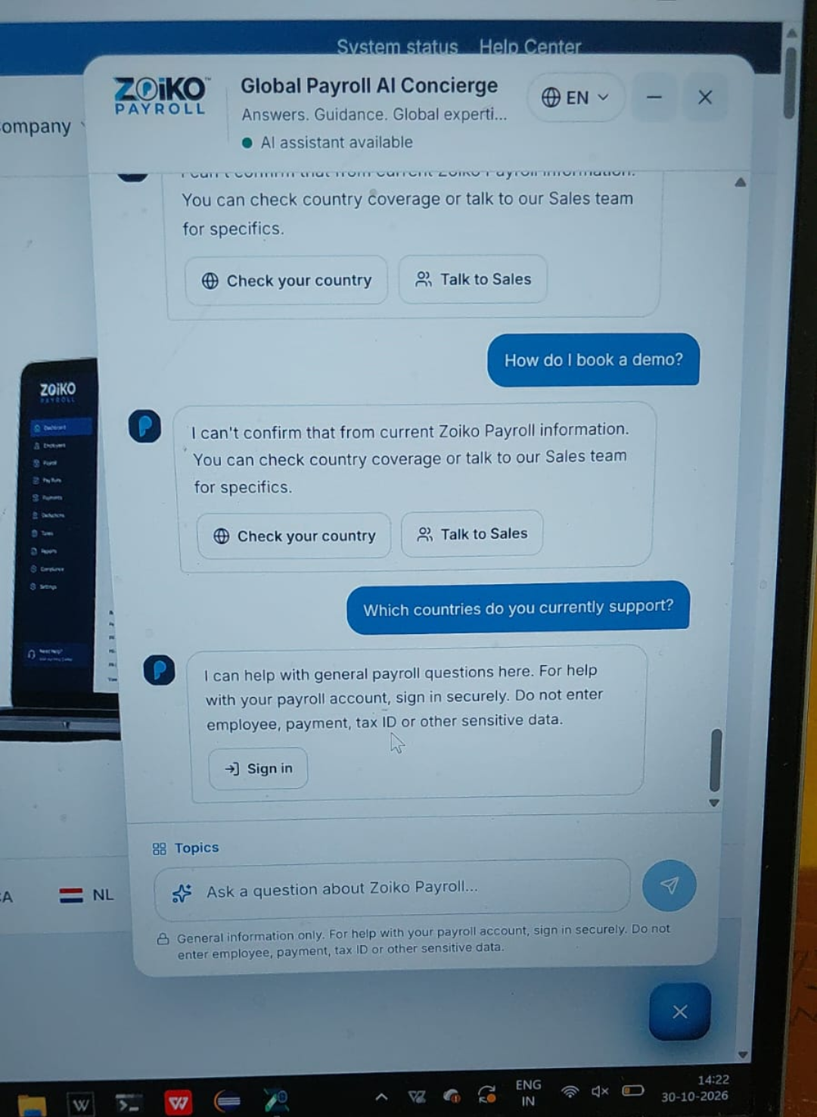  Figure 5: No answer for demo booking; "Which countries do you currently support?" asks to sign in | 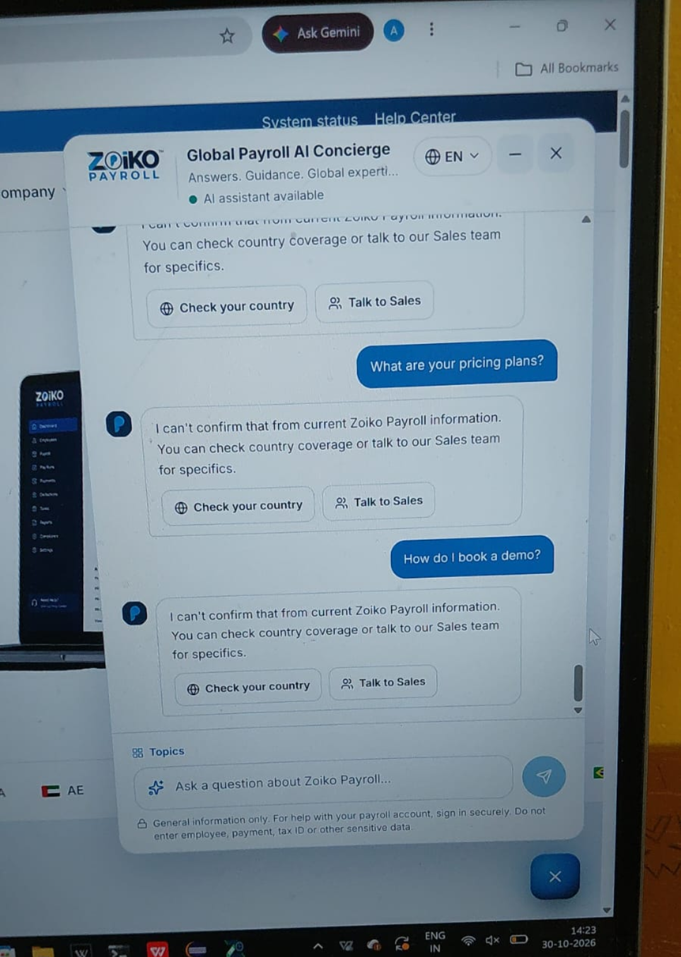  Figure 6: Pricing plans and demo booking not answered

BUG-02: "Check your country" section disabled for some questions
Bug ID | BUG-02
Severity | High
Status | Open
Description | In the "Check your country" section, the "Search a country…" field is disabled (a not-allowed cursor appears), so users cannot select a country. This blocks checking country support and viewing local payroll and compliance information.
Screenshots
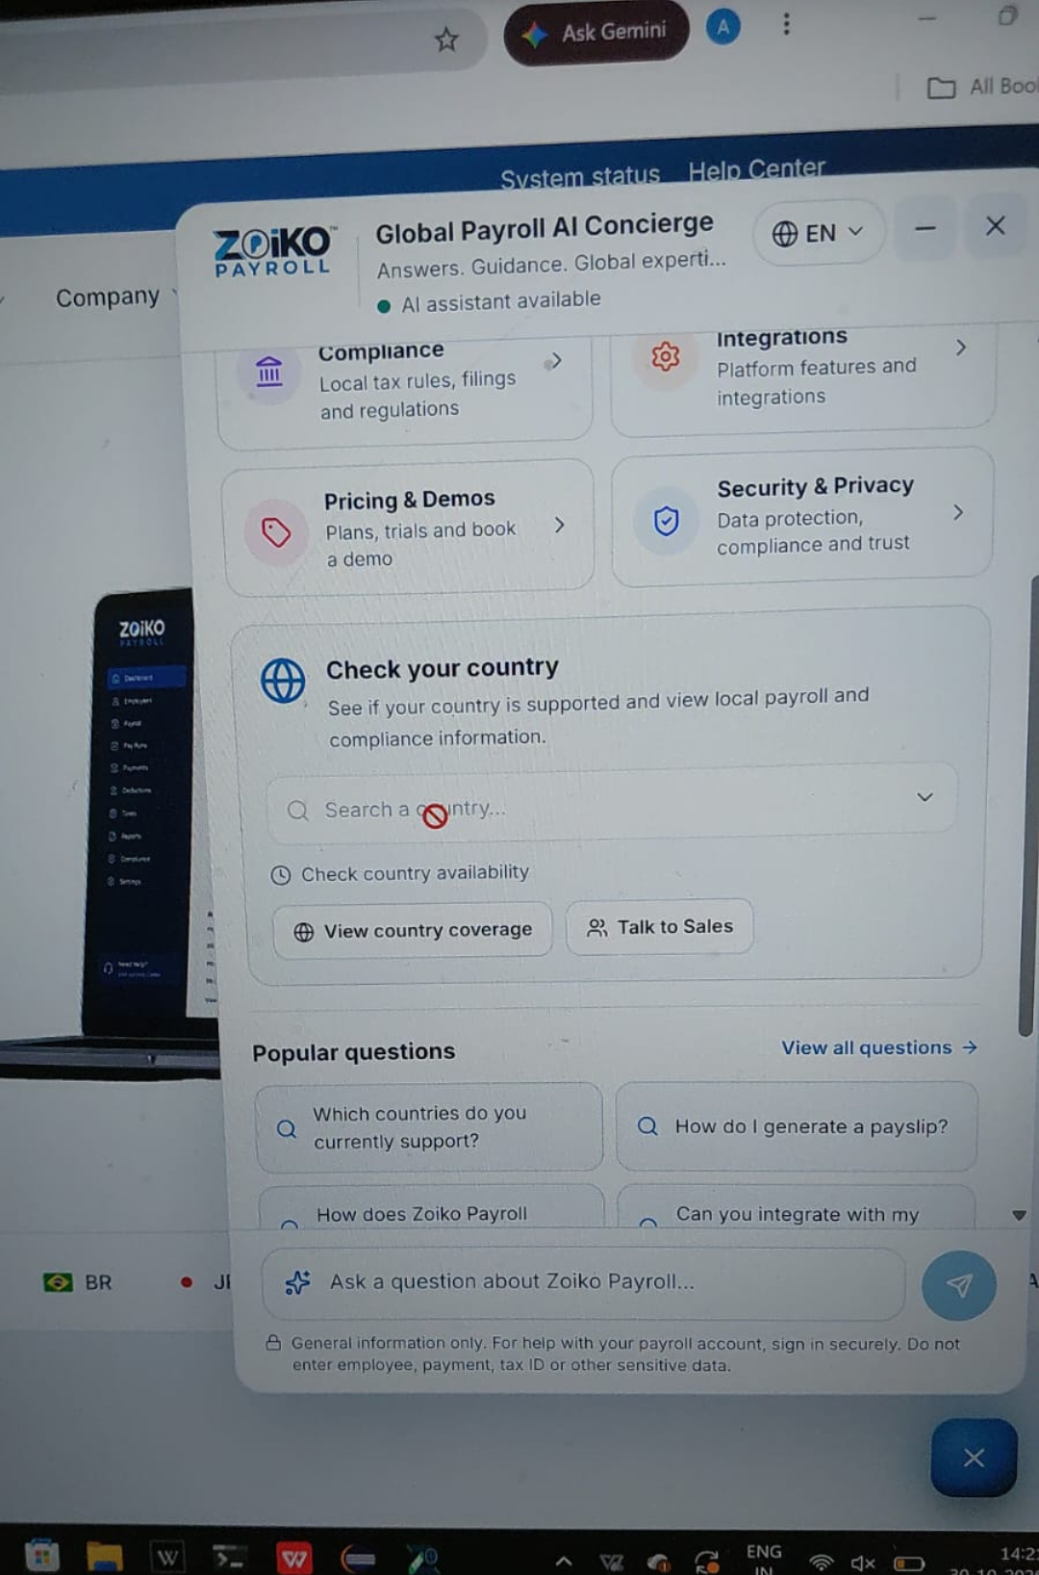
Figure 7: Country search field disabled in the chatbot

